GATE Questions On ADS
1) The number of distinct minimum spanning trees for the weighted graph below is ____
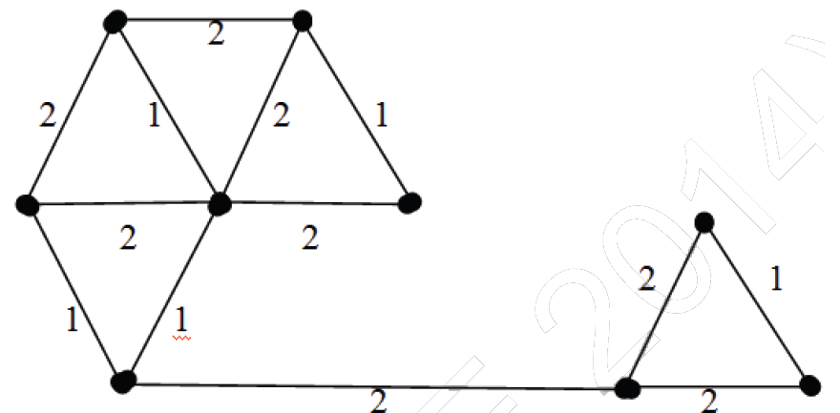
Answer: 6
Highlighted (in green) are the edges picked to make a MST. In the right side of MST, we could either pick edge ‘a’ or ‘b’. In the left side, we could either pick ‘c’ or ‘d’ or ‘e’ in MST.
There are 2 options for one edge to be picked and 3 options for another edge to be picked. Therefore, total 2*3 possible MSTs.
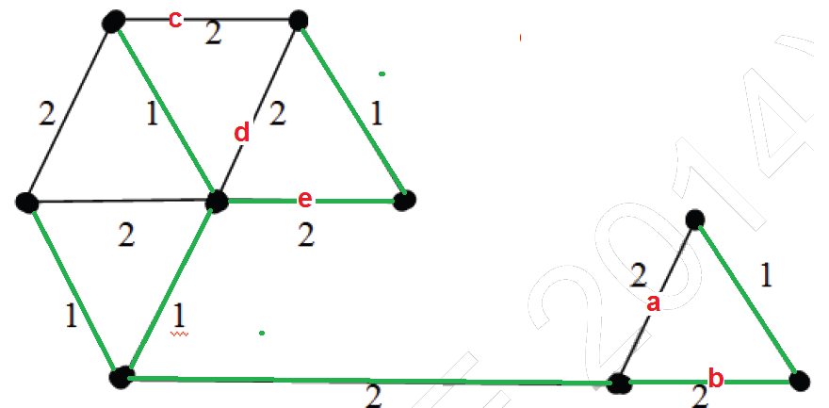
2) Consider the following rooted tree with the vertex P labeled as root
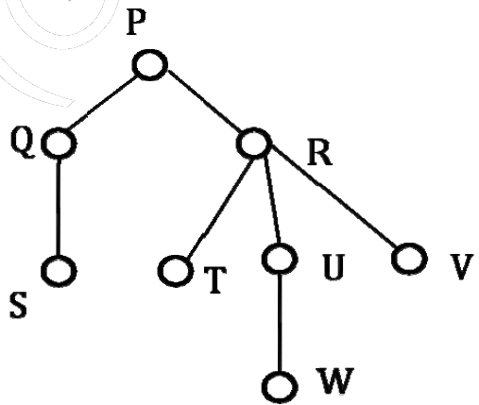
The order in which the nodes are visited during in-order traversal is
(A) SQPTRWUV
(B) SQPTURWV
(C) SQPTWUVR
(D) SQPTRUWV
Answer: (A)
The only confusion in this question is, there are 3 children of R. So when should R appear – after U or after R? There are two possibilities: SQPTRWUV and SQPTWURV. Only 1st possibility is present as an option A, the IInd possibility is not there. Therefore option A is the right answer.
3) Let A be a square matrix of size n x n. Consider the following program. What is the expected output?
C = 100
for i = 1 to n do
for j = 1 to n do
{
Temp = A[i][j] + C
A[i][j] = A[j][i]
A[j][i] = Temp - C
}
for i = 1 to n do
for j = 1 to n do
Output(A[i][j]);
(A) The matrix A itself
(B) Transpose of matrix A
(C) Adding 100 to the upper diagonal elements and subtracting 100 from diagonal elements of A
(D) None of the above
Answer: A
If we take look at the inner statements of first loops, we can notice that the statements swap A[i][j] and A[j][i] for all i and j.
Since the loop runs for all elements, every element A[l][m] would be swapped twice, once for i = l and j = m and then for i = m and j = l. Swapping twice means the matrix doesn’t change.
4) The minimum number of arithmetic operations required to evaluate the polynomial P(X) = X⁵ + 4X³ + 6X + 5 for a given value of X using only one temporary variable.
(A) 6
(B) 7
(C) 8
(D) 9
Answer: B
We can parenthesize the polynomial to minimize the number of operations (See Horner’s Method). We get X(X²(X² + 4) + 6) + 5 after parenthesization.
Following is sequence of operations to be used.
Note that we are allowed to use only one variable.
res = X*X
res = res + 4
res = X*res
res = X*res
res = res + 6
res = X*res
res = res + 5
5) You have an array of n elements. Suppose you implement quicksort by always choosing the central element of the array as the pivot. Then the tightest upper bound for the worst case performance is
(A) O(n²)
(B) O(nLogn)
(C) Θ(nLogn)
(D) O(n³)
Answer: (A)
1) Let G be a graph with n vertices and m edges. What is the tightest upper bound on the running time on Depth First Search of G? Assume that the graph is represented using adjacency matrix.
(A) O(n)
(B) O(m+n)
(C) O(n²)
(D) O(mn)
Answer: (C)
Explanation: Depth First Search of a graph takes O(m+n) time when the graph is represented using adjacency list.
In adjacency matrix representation, graph is represented as an “n x n” matrix. To do DFS, for every vertex, we traverse the row corresponding to that vertex to find all adjacent vertices (In adjacency list representation we traverse only the adjacent vertices of the vertex). Therefore time complexity becomes O(n²)
2) Consider a rooted Binary tree represented using pointers. The best upper bound on the time required to determine the number of subtrees having having exactly 4 nodes O(nª Logn ^{b}). Then the value of a + 10b is ________
Answer: 1
Explanation: We can find the subtree with 4 nodes in O(n) time. Following can be a simple approach.
1) Traverse the tree in bottom up manner and find size of subtree rooted with current node
2) If size becomes 4, then print the current node.
int print4Subtree(struct Node *root)
{
if (root == NULL)
return 0;
int l = print4Subtree(root->left);
int r = print4Subtree(root->right);
if ((l + r + 1) == 4)
printf("%d ", root->data);
return (l + r + 1);
}
3) Consider the directed graph given below. Which one of the following is TRUE?
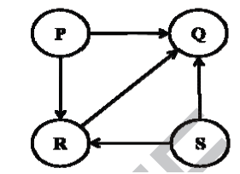
(A) The graph doesn’t have any topological ordering
(B) Both PQRS and SRPQ are topological ordering
(C) Both PSRQ and SPRQ are topological ordering
(D) PSRQ is the only topological ordering
Answer: (C)
Explanation: The graph doesn’t contain any cycle, so there exist topological ordering.
P and S must appear before R and Q because there are edges from P to R and Q, and from S to R and Q.
See Topological Ordering for more details.
4) Let P be a QuickSort Program to sort numbers in ascending order using the first element as pivot. Let t1 and t2 be the number of comparisons made by P for the inputs {1, 2, 3, 4, 5} and {4, 1, 5, 3, 2} respectively. Which one of the following holds?
(A) t1 = 5
(B) t1 < t2
(C) t1 > t2
(D) t1 = t2
Answer: (C)
Explanation: When first element or last element is chosen as pivot, Quick Sort‘s worst case occurs for the sorted arrays.
In every step of quick sort, numbers are divided as per the following recurrence.
T(n) = T(n-1) + O(n)
5) Consider the following C function in which size is the number of elements in the array E:
The value returned by the function MyX is the
int MyX(int *E, unsigned int size)
{
int Y = 0;
int Z;
int i, j, k;

for (i = 0; i < size; i++)
Y = Y + E[i];

for (i = 0; i < size; i++)
for (j = i; j < size; j++)
{
Z = 0;
for (k = i; k <= j; k++)
Z = Z + E[k];
if (Z > Y)
Y = Z;
}
return Y;
}
(A) maximum possible sum of elements in any sub-array of array E.
(B) maximum element in any sub-array of array E.
(C) sum of the maximum elements in all possible sub-arrays of array E
(D) the sum of all the elements in the array E.
Answer: (A)
Explanation: The function does following
Y is used to store maximum sum seen so far and Z is used to store current sum
1) Initialize Y as sum of all elements
2) For every element, calculate sum of all subarrays starting with arr[i]. Store the current sum in Z. If Z is greater than Y, then update Y.
See following for complete solutions of all GATE CS 2014 papers
) Consider the tree arcs of a BFS traversal from a source node W in an unweighted, connected, undirected graph. The tree T formed by the tree arcs is a data structure for computing.
(A) the shortest path between every pair of vertices.
(B) the shortest path from W to every vertex in the graph.
(C) the shortest paths from W to only those nodes that are leaves of T.
(D) the longest path in the graph
Answer: (B)
BFS always produces shortest paths from source to all other vertices in an unweighted graph. The reason is simple, in BFS, we first explore all vertices which are 1 edge away from source, then we explore all vertices which are 2 edges away from the source and so on. This property of BFS makes it useful in many algorithms like Edmonds–Karp algorithm.
2) Consider the following pseudo code. What is the total number of multiplications to be performed?
D = 2
for i = 1 to n do
for j = i to n do
for k = j + 1 to n do
D = D * 3
(A) Half of the product of the 3 consecutive integers.
(B) One-third of the product of the 3 consecutive integers.
(C) One-sixth of the product of the 3 consecutive integers.
(D) None of the above.
Answer (C)
The statement “D = D * 3” is executed n*(n+1)*(n-1)/6 times. Let us see how.
For i = 1, the multiplication statement is executed (n-1) + (n-2) + .. 2 + 1 times.
For i = 2, the statement is executed (n-2) + (n-3) + .. 2 + 1 times
………………………..
……………………….
For i = n-1, the statement is executed once.
For i = n, the statement is not executed at all
So overall the statement is executed following times
[(n-1) + (n-2) + .. 2 + 1] + [(n-2) + (n-3) + .. 2 + 1] + … + 1 + 0
The above series can be written as
S = [n*(n-1)/2 + (n-1)*(n-2)/2 + ….. + 1]
The sum of above series can be obtained by trick of subtraction the series from standard Series S1 = n² + (n-1)² + .. 1². The sum of this standard series is n*(n+1)*(2n+1)/6
S1 – 2S = n + (n-1) + … 1 = n*(n+1)/2
2S = n*(n+1)*(2n+1)/6 – n*(n+1)/2
S = n*(n+1)*(n-1)/6
3) Consider a hash table with 9 slots. The hash function is h(k) = k mod 9. The collisions are resolved by chaining. The following 9 keys are inserted in the order: 5, 28, 19, 15, 20, 33, 12, 17, 10. The maximum, minimum, and average chain lengths in the hash table, respectively, are
(A) 3, 0, and 1
(B) 3, 3, and 3
(C) 4, 0, and 1
(D) 3, 0, and 2
Answer: (A)
Following are values of hash function for all keys
5 --> 5
28 --> 1
19 --> 1 [Chained with 28]
15 --> 6
20 --> 2
33 --> 6 [Chained with 15]
12 --> 3
17 --> 8
10 --> 1 [Chained with 28 and 19]
The maximum chain length is 3. The keys 28, 19 and 10 go to same slot 1, and form a chain of length 3.
The minimum chain length 0, there are empty slots (0, 4 and 7).
Average chain length is (0 + 3 + 1 + 1 + 0 + 1 + 2 + 0 + 1)/9 = 1
4) A priority queue is implemented as a Max-Heap. Initially, it has 5 elements. The level-order traversal of the heap is: 10, 8, 5, 3, 2. Two new elements 1 and 7 are inserted into the heap in that order. The level-order traversal of the heap after the insertion of the elements is:
(A) 10, 8, 7, 3, 2, 1, 5
(B) 10, 8, 7, 2, 3, 1, 5
(C) 10, 8, 7, 1, 2, 3, 5
(D) 10, 8, 7, 5, 3, 2, 1
Answer: (A)
Initially heap has 10, 8, 5, 3, 2
10
/ \
8 5
/ \
3 2

After insertion of 1
10
/ \
8 5
/ \ /
3 2 1
No need to heapify as 5 is greater than 1.

After insertion of 7
10
/ \
8 5
/ \ / \
3 2 1 7
Heapify 5 as 7 is greater than 5
10
/ \
8 7
/ \ / \
3 2 1 5
No need to heapify any further as 10 is
greater than 7
5) Which one of the following correctly determines the solution of the recurrence relation with T(1) = 1?
T(n) = 2T(n/2) + Logn
(A) Θ(n)
(B) Θ(nLogn)
(C) Θ(n*n)
(D) Θ(log n)
Answer: (A)
This can be solved using Master Method. It falls in case 1.
7) Suppose implementation supports an instruction REVERSE, which reverses the order of elements on the stack, in addition to the PUSH and POP instructions. Which one of the following statements is TRUE with respect to this modified stack?
(A) A queue cannot be implemented using this stack.
(B) A queue can be implemented where ENQUEUE takes a single instruction and DEQUEUE takes a sequence of two instructions.
(C) A queue can be implemented where ENQUEUE takes a sequence of three instructions and DEQUEUE takes a single instruction.
(D) A queue can be implemented where both ENQUEUE and DEQUEUE take a single instruction each.
Answer: (C)
1) Which of the following statements is/are TRUE for an undirected graph?
P: Number of odd degree vertices is even
Q: Sum of degrees of all vertices is even
A) P Only
B) Q Only
C) Both P and Q
D) Neither P nor Q
Answer (C)
Q is true: Since the graph is undirected, every edge increases the sum of degrees by 2.
P is true: If we consider sum of degrees and subtract all even degrees, we get an even number (because Q is true). So total number of odd degree vertices must be even.
2) Consider an undirected random graph of eight vertices. The probability that there is an edge between a pair of vertices is 1/2. What is the expected number of unordered cycles of length three?
(A) 1/8
(B) 1
(C) 7
(D) 8
Answer (C)
A cycle of length 3 can be formed with 3 vertices. There can be total 8C3 ways to pick 3 vertices from 8. The probability that there is an edge between two vertices is 1/2. So expected number of unordered cycles of length 3 = (8C3)*(1/2)^3 = 7
3) What is the time complexity of Bellman-Ford single-source shortest path algorithm on a complete graph of n vertices?
(A) Θ(n²)
(B) Θ(n² Logn)
(C) Θ(n³)
(D) Θ(n³ Logn)
Answer (C).
Time complexity of Bellman-Ford algorithm is Θ(VE) where V is number of vertices and E is number edges (See this). If the graph is complete, the value of E becomes Θ(V²). So overall time complexity becomes Θ(V³)
4) Which of the following statements are TRUE?
(1) The problem of determining whether there exists a cycle in an undirected graph is in P.
(2) The problem of determining whether there exists a cycle in an undirected graph is in NP.
(3) If a problem A is NP-Complete, there exists a non-deterministic polynomial time algorithm to solve A.
(A) 1,2 and 3
(B) 1 and 2 only
(C) 2 and 3 only
(D) 1 and 3 only
Answer (A)
1 is true because cycle detection can be done in polynomial time using DFS (See this).
2 is true because P is a subset of NP.
3 is true because NP complete is also a subset of NP and NP means Non-deterministic Polynomial time solution exists. (See this)
5) Which one of the following is the tightest upper bound that represents the time complexity of inserting an object into a binary search tree of n nodes?
(A) O(1)
(B) O(log n)
(C) O(n)
(D) O(n log n)
Answer (C)
The worst case occurs for a skewed tree. In a skewed tree, when a new node is inserted as a child of bottommost node, the time for insertion requires traversal of all node. For example, consider the following tree and the case when something smaller than 70 is inserted.
100
/
90
/
80
/
70
6) Which one of the following is the tightest upper bound that represents the number of swaps required to sort n numbers using selection sort?
(A) O(log n)
(B) O(n)
(C) O(n log n)
(D) O(n^2)
Answer (B)
Selection sort requires only O(n) swaps. See this for details.
7) Consider the following operation along with Enqueue and Dequeue operations on
queues, where k is a global parameter
MultiDequeue(Q){
m = k
while (Q is not empty and m > 0) {
Dequeue(Q)
m = m - 1
}
}

What is the worst case time complexity of a sequence of n MultiDequeue() operations on an initially empty queue?
(A) Θ(n)
(B) Θ(n + k)
(C) Θ(nk)
(D) Θ(n²)
Answer (A)
Since the queue is empty initially, the condition of while loop never becomes true. So the time complexity is Θ(n)
) What is the return value of f(p, p) if the value of p is initialized to 5 before the call? Note that the first parameter is passed by reference, whereas the second parameter is passed by value.
int f(int &x, int c) {
c = c - 1;
if (c == 0) return 1;
x = x + 1;
return f(x, c) * x;
}
(A) 3024
(B) 6561
(C) 55440
(D) 161051
Answer (B)
Since c is passed by value and x is passed by reference, all functions will have same copy of x, but different copies of c.
f(5, 5) = f(x, 4)*x = f(x, 3)*x*x = f(x, 2)*x*x*x = f(x, 1)*x*x*x*x = 1*x*x*x*x = x^4
Since x is incremented in every function call, it becomes 9 after f(x, 2) call. So the value of expression x^4 becomes 9^4 which is 6561.
#include <stdio.h>

int f(int &x, int c)
{
c = c - 1;
if (c == 0) return 1;
x = x + 1;
return f(x, c) * x;
}
int main()
{
int p = 5;
printf("%d", f(p, p));
}
1) The preorder traversal sequence of a binary search tree is 30, 20, 10, 15, 25, 23, 39, 35, 42. Which one of the following is the postorder traversal sequence of the same tree?
(A) 10, 20, 15, 23, 25, 35, 42, 39, 30
(B) 15, 10, 25, 23, 20, 42, 35, 39, 30
(C) 15, 20, 10, 23, 25, 42, 35, 39, 30
(D) 15, 10, 23, 25, 20, 35, 42, 39, 30
Ans (D)
The following is the constructed tree
30
/ \
20 39
/ \ / \
10 25 35 42
\ /
15 23
3) Consider the following function
int unknown(int n) {
int i, j, k = 0;
for (i = n/2; i <= n; i++)
for (j = 2; j <= n; j = j * 2)
k = k + n/2;
return k;
}
What is the returned value of the above function?
(A) Θ(n^2)
(B) Θ(n^2Logn)
(C) Θ(n^3)
(D) Θ(n^3Logn)
Answer (B)
The outer loop runs n/2 or Θ(n) times. The inner loop runs Θ(Logn) times (Note that j is divide by 2 in every iteration). So the statement "k = k + n/2;" runs Θ(nLogn) times. The statement increases value of k by n/2. So the value of k becomes n/2*Θ(nLogn) which is Θ(n^2Logn)
4) The number of elements that can be sorted in Θ(logn) time using heap sort is
(A) Θ(1)
(B) Θ(sqrt(logn))
(C) Θ(Log n/(Log Log n))
(d) Θ(Log n)
Answer (C)
Time complexity of Heap Sort is Θ(mLogm) for m input elements. For m = Θ(Log n/(Log Log n)), the value of Θ(m * Logm) will be Θ( [Log n/(Log Log n)] * [Log (Log n/(Log Log n))] ) which will be Θ( [Log n/(Log Log n)] * [ Log Log n - Log Log Log n] ) which is Θ(Log n)
5) The procedure given below is required to find and replace certain characters inside an input character string supplied in array A. The characters to be replaced are supplied in array oldc, while their respective replacement characters are supplied in array newc. Array A has a fixed length of five characters, while arrays oldc and newc contain three characters each. However, the procedure is flawed
void find_and_replace(char *A, char *oldc, char *newc) {
for (int i = 0; i < 5; i++)
for (int j = 0; j < 3; j++)
if (A[i] == oldc[j]) A[i] = newc[j];
}
The procedure is tested with the following four test cases
(1) oldc = "abc", newc = "dab"
(2) oldc = "cde", newc = "bcd"
(3) oldc = "bca", newc = "cda"
(4) oldc = "abc", newc = "bac"
The tester now tests the program on all input strings of length five consisting of characters ‘a’, ‘b’, ‘c’, ‘d’ and ‘e’ with duplicates allowed. If the tester carries out this testing with the four test cases given above, how many test cases will be able to capture the flaw?
(A) Only one
(B) Only two
(C) Only three
(D) All four
Answer (B)
The test cases 3 and 4 are the only cases that capture the flaw. The code doesn't work properly when an old character is replaced by a new character and the new character is again replaced by another new character. This doesn't happen in test cases (1) and (2), it happens only in cases (3) and (4).
6) If array A is made to hold the string “abcde”, which of the above four test cases will be successful in exposing the flaw in this procedure?
(A) None
(B) 2 only
(C) 3 and 4 only
(D) 4 only
Answer (C)
#include <stdio.h>
#include <string.h>

void find_and_replace(char *A, char *oldc, char *newc) {
for (int i = 0; i < 5; i++)
for (int j = 0; j < 3; j++)
if (A[i] == oldc[j]) A[i] = newc[j];
}

int main()
{
char *oldc1 = "abc", *newc1 = "dab";
char *oldc2 = "cde", *newc2 = "bcd";
char *oldc3 = "bca", *newc3 = "cda";
char *oldc4 = "abc", *newc4 = "bac";

char test[] = "abcde";

printf("Test 2\n");
printf("%s\n", test);
find_and_replace(test, oldc2, newc2);
printf ("%s\n", test);

printf("\nTest 3\n");
strcpy(test, "abcde");
printf("%s\n", test);
find_and_replace(test, oldc3, newc3);
printf ("%s\n", test);

printf("\nTest 4\n");
strcpy(test, "abcde");
printf("%s\n", test);
find_and_replace(test, oldc4, newc4);
printf ("%s\n", test);
}
Output:
Test 2
abcde
abbcd

Test 3
abcde
addde

Test 4
abcde
aacde

